Final Project

**Project Description**: this project will take the image chosen by the users as an input and try to identify which object category is the best match for a given test image.

**Data set**: the data set we are intended to use is the Caltech 256 dataset, containing The Caltech 256 dataset contains images of 256 object categories taken at varying orientations, varying lighting conditions, and with different backgrounds. For example, there is a category named backpacks and the following images are taken directly from the data set. We can see that there are not only real photos taken by a camera, but also cartoons.

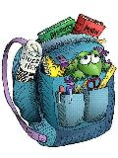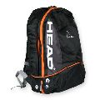

(<http://www.vision.caltech.edu/Image_Datasets/Caltech256/>)

**Algorithms**: since we have not learned any algorithms for classification problem, we do not have a clear idea of what machine learning algorithms we should use. However, the promising candidates are neutral networks (since it is a quite powerful method in dealing with images) and clustering methods such as K-nearest-neighbor.

**Limitations and problems**: since we only have 256 categories in our dataset, it is very likely that the image that users input is not in any of the categories. This might lead to a low accuracy. In addition, some of the categories have limited number of images, which will also lower the accuracy of classification.